**Project Report**

**Topic: Groundwater in different Region**

**Submitted To:**

Md. Erfan

Chairman & Assistant Professor

Department of Computer Science & Engineering

University of Barishal

Cell: 01799598455

Email: irfan.bucse@gmail.com

**Submitted By:**

Name : Mahmudul Hasan

Roll : 01-43-06

Department : Geology & Mining

Course : Computer Fundamental and Office Application

Batch : 43

Contents

1.Introduction 3

2.Dataset Preparation 4

3. Methodology 5

3.1 Data Preprocessing 5

3.2 Exploratory Data Analysis (EDA) 5

3.3 Model Evaluation 5

3.4 Model Selection and Training 6

3. 5 Sensitivity Analysis 6

3.4 Data Transformation 7

4.Results 7

4.1 Preliminery Modeling 7

4.2 Validating Assumptions of Groundwater 8

5.Conclusion 10

# 1.Introduction

Groundwater is an invaluable resource that sustains drinking water supplies, agricultural irrigation, and industrial processes, particularly in areas where surface water is scarce or unreliable. However, the quality of groundwater is subject to a wide range of factors that can affect its safety, usability, and long-term sustainability. Monitoring and understanding these factors is essential for ensuring safe water access and addressing the growing challenges posed by water contamination and depletion.

Groundwater is a critical resource supporting agriculture, domestic, and industrial needs across diverse regions. Its characteristics, including depth, recharge rates, and seasonal fluctuations, vary significantly, with regions like North-central experiencing arsenic contamination and moderate recharge, while coastal areas face severe salinity and heavy metal pollution due to sea-level rise. Over-extraction in some areas further exacerbates challenges, reducing natural recharge rates. These issues highlight the need for sustainable management practices tailored to regional conditions to safeguard groundwater for future use.

It plays a vital role in sustaining life and livelihoods, serving as a key resource for irrigation, drinking, and industry. However, its availability and quality vary by region. In North-central areas, arsenic contamination and fluctuating recharge rates pose challenges, while coastal regions grapple with salinity and heavy metal intrusion due to sea-level rise. Seasonal changes and over-extraction further strain this critical resource, emphasizing the urgency of effective management to ensure long-term sustainability.

# 2.Dataset Preparation

I used datasets from different sources for our project. I want to explore which region have much suitable for groundwater.

Firsty, I collected datasets from different regions of groundwater for our project. These datasets contain various information about key parameters such as pH levels, salinity, nitrate contamination, water hardness, temperature ranges, and water source types. The data also includes geographical information for each region, including district names and sample locations. Additionally, the datasets contain records of contamination remarks (e.g., arsenic, nitrate), groundwater levels over time, and measurements of specific elements that can impact water quality. By analyzing these parameters across multiple regions, I aim to identify areas where groundwater quality is optimal for use and highlight regions where treatment or other interventions may be needed to ensure safe and sustainable water resources.

By analyzing these diverse parameters across multiple regions, I aim to identify regions that are most suitable for groundwater use, where water quality is consistent and falls within safe limits. This will help determine areas where groundwater is abundant and of high quality, and also highlight regions that may require intervention, like water treatment, improved monitoring, or contamination remediation strategies. The project will provide actionable insights for decision-makers to ensure sustainable groundwater management, assess risks, and prioritize regions for investment in infrastructure to maintain safe and clean water resources.

# 3. Methodology

In this chapter, i will talk about the methodology used for my work.

## 3.1 Data Preprocessing

Data preprocessing is a critical step in preparing the groundwater dataset for analysis. The goal of preprocessing is to clean, transform, and organize the data in a way that facilitates meaningful analysis, ensuring that the final dataset is accurate, consistent, and ready for exploration.

## 3.2 Exploratory Data Analysis (EDA)

EDA is a critical part of the methodology where you explore and visualize the data to understand the underlying patterns, trends, and relationships between different variables. Generating graphs (scatter plots, histograms, heat maps, time series plots) to explore the distribution of groundwater parameters. Calculating basic statistics such as mean, median, standard deviation, skewness, and kurtosis to understand the data's central tendency and variability. Examining correlations between groundwater quality parameters (pH vs. salinity, nitrate vs. hardness) to identify any interdependencies. Analyzing data spatially, especially when monitoring different regions or districts, to identify areas with specific groundwater concerns (areas with high salinity or contamination).

## 3.3 Model Evaluation

The performance of the model(s) is assessed using appropriate metrics based on the type of problem (regression or classification). Common evaluation techniques include:

For Regression Models: Metrics like R-squared, Mean Squared Error (MSE), Mean Absolute Error (MAE), and Root Mean Squared Error (RMSE) help measure the accuracy and fit of the model.

For Classification Models: Metrics such as accuracy, precision, recall, F1-score, and ROC-AUC curve are used to evaluate the classification performance.

Cross-Validation: Cross-validation techniques like k-fold cross-validation can be applied to ensure the model generalizes well to unseen data.

## 3.4 Model Selection and Training

Based on the research objectives, various models are selected for predicting or understanding groundwater behavior. If the goal is to predict groundwater parameters (salinity, pH, nitrate), regression models (linear regression, random forests, gradient boosting) or machine learning models (support vector machines, neural networks) are typically used. If the goal is to classify water samples as safe or unsafe, classification algorithms like logistic regression, decision trees, or random forests can be applied. If analyzing the temporal behavior of groundwater levels, time series models such as ARIMA or LSTM (Long Short-Term Memory networks) can be used. For spatial analysis, models like kriging or geographically weighted regression (GWR) can be employed to understand the distribution of groundwater parameters across regions.

## 3. 5 Sensitivity Analysis

Groundwater systems are highly sensitive to environmental and anthropogenic factors. Sensitivity analysis helps identify which variables (rainfall, land use, temperature) most influence the groundwater behavior. It can be done by:

**Modeling Input Variability:** Changing one variable at a time while keeping others constant to see its effect on the groundwater outcome (salinity or nitrate levels).

**Uncertainty Quantification:** Assessing how uncertainties in input data (such as missing data or measurement errors) affect model predictions.

## 3.4 Data Transformation

Normalization or scaling of variables to bring them to a similar range, if required for modeling.

● Natural Logarithm

● Exponential

● Square Root

● Cubic Root

● Inverse

# 4.Results

In this chapter, we will discuss and analyze the results and findings of our work.

## 4.1 Preliminery Modeling

We created a dataset that compare water quality metrics across different districts. The table summarizes water quality metrics across districts, showing variations in groundwater levels, pH, salinity, and other key parameters. Patuakhali has the highest groundwater level (54.69 m), while Rajshahi is lowest (47.41 m). Salinity is a concern in Sylhet (17.72 ppt) and Cox’s Bazar (17.64 ppt), potentially limiting agricultural use. Mymensingh has the highest arsenic concentration (53.86 µg/L), and Sylhet exhibits the highest nitrate levels (26.46 mg/L), highlighting potential health risks. Hard water is notable in Cox’s Bazar (289.99 ppm), and iron levels are slightly elevated in Rangpur (5.48 mg/L). Overall, some districts may require water treatment for safe consumption and usage

|  |  |  |  |  |  |  |  |  |
| --- | --- | --- | --- | --- | --- | --- | --- | --- |
| **District** | **Groundwater Level (m)** | **pH Level** | **Arsenic Concentration (µg/L)** | **Water Temp (°C)** | **Salinity (ppt)** | **Water Hardness (ppm)** | **Iron Content (mg/L)** | **Nitrate Content (mg/L)** |
| Cox's Bazar | 50.27 | 7.44 | 49.18 | 27.33 | 17.64 | 289.99 | 5.16 | 25.10 |
| Gazipur | 53.36 | 7.50 | 51.77 | 26.84 | 17.99 | 269.75 | 5.09 | 25.05 |
| Khulna | 49.32 | 7.34 | 48.99 | 26.98 | 17.30 | 275.56 | 4.88 | 25.62 |
| Mymensingh | |  | | --- | |  |  |  | | --- | | 51.19 | | 7.49 | 53.86 | 27.26 | 16.50 | 259.56 | 4.93 | 24.34 |
| Patuakhali | 54.69 | 7.52 | 48.75 | 27.08 | 17.27 | 268.74 | 4.94 | 26.22 |
| Rajshahi | |  | | --- | |  |  |  | | --- | | 47.41 | | 7.48 | 50.11 | 27.34 | 16.66 | 283.74 | 4.83 | 25.94 |
| Rangpur | |  | | --- | |  |  |  | | --- | | 52.69 | | 7.46 | 50.02 | 26.79 | 16.78 | 270.17 | 5.48 | 23.24 |
| Sylhet | |  | | --- | |  |  |  | | --- | | 50.87 | | 7.53 | 49.27 | 27.28 | 17.72 | 274.64 | 5.03 | 26.46 |

**Figure 1:** water quality metrics across different district

## 4.2 Validating Assumptions of Groundwater

I checked the data using scatter plots. Some variables seemed to haveNitrate Content (mg/L) vs Water Hardness (ppm). However, most variables did not present a clear linear relationship in the scatter plots.

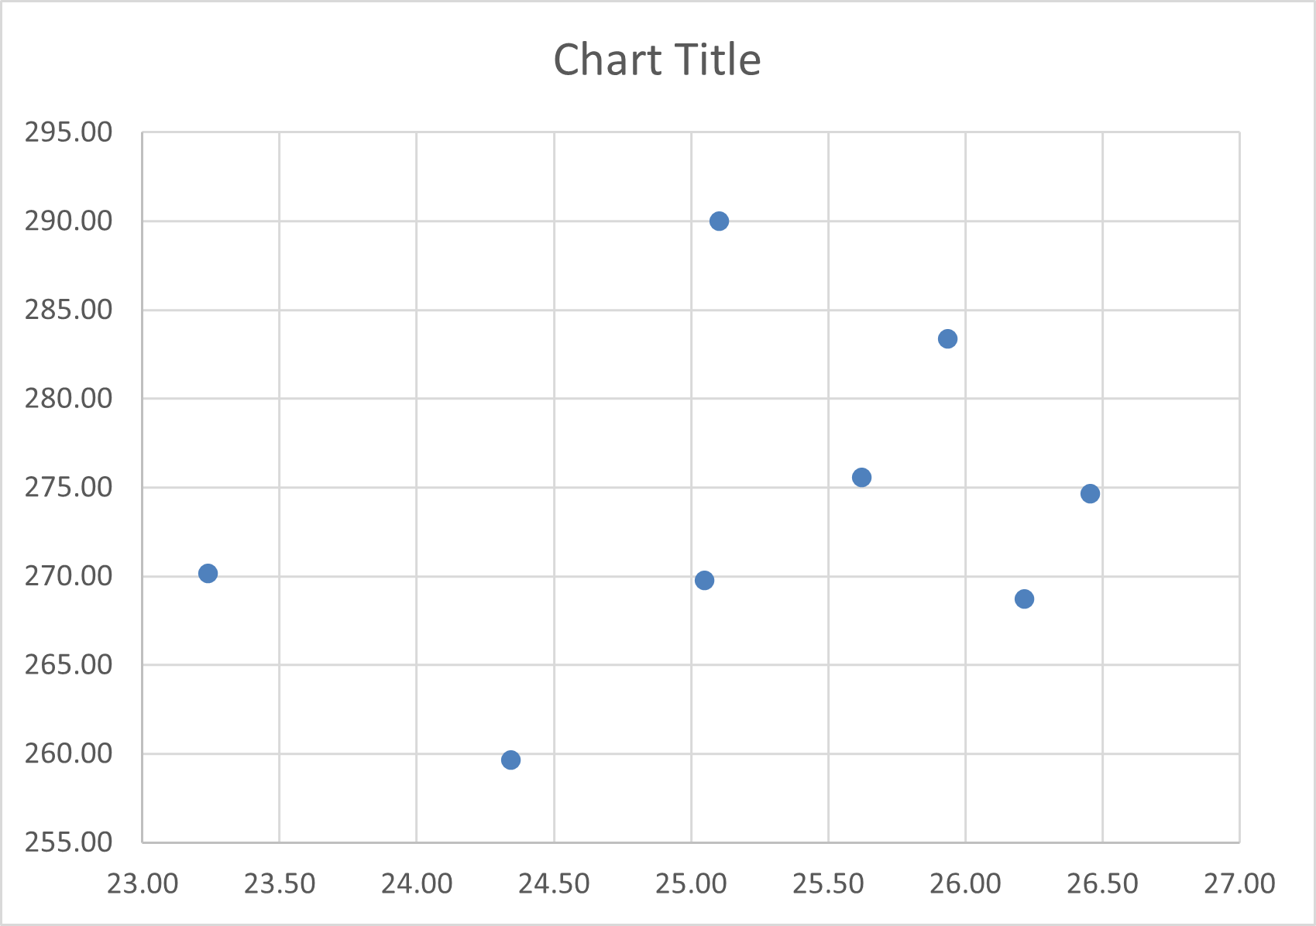

**Figure 2: Nitrate Content (mg/L) vs Water Hardness (ppm)**

Figure 3: Groundwater level in different district

Figure 4: pH level

Figure 5: Arsenic Contamination

# 5.Conclusion

Groundwater is an invaluable resource that underpins agriculture, industry, and daily life, particularly in regions with limited surface water availability. Its significance is especially evident in countries like Bangladesh, where groundwater serves as the primary source for irrigation and drinking water. However, the sustainability of groundwater resources is increasingly under threat due to overextraction, pollution, and the impacts of climate change. The analysis of groundwater depth and quality across different regions highlights significant spatial variability, influenced by factors such as geological formations, land use, and human activity. Regions experiencing overuse or contamination require immediate attention to prevent further degradation of this critical resource. Key issues, such as falling water tables, arsenic contamination, and salinity intrusion, underscore the urgent need for sustainable management practices.